CONCLUSIONS
Tried overcoming the interface region using three methods:

- Interpolation according to excitation profile
  - Excite the interface region only partially
  - During PP reconstruct the interface region by dividing the signal by the excitation profile.

This option does not work well
- During excitation we loose part of the signal
- It is hard to match the non-excited region width and shape to the interface dimensions.
- The wiggling issue is not addressed or solved using this method

- Phase based interpolation – taking into consideration the entire other half of the sample

Option 2.1
  - For each SP
  - For each side of the sample
  - For each point on that side
    - Calculate the phase profile of the other side of the sample, at the time that this point was acquired.
    - Integrate the other side of the sample and add the result to this point.
  - Use the resulting signal as a basis for next iterations of the same process
  - Use the result from the last iteration as a basis for correcting the initial signal.

This option gives semi-satisfactory results.
- The signal level, at the interface region can be returned to its initial value.
- The wiggles do not disappear.
- The wiggling region retains its width.
- The parameter adjustment is not trivial. An interpolation factor should be manually adjusted in order for the signal at the interface level to be correctly returned to normal.
- The entire reconstructed signal becomes noisier so that LPF must e applied to the image in order to remove this artifact.

Option 2.2
Same as the previous option, but instead of using the acquired signal as an initial result, use a sample of ones.
  - For each SP
  - For each side of the sample
  - For each point on that side
    - Calculate the phase profile of the other side of the sample, at the time that this point was acquired.
    - Integrate the other side of the sample and add the result to this point.
  - Perform only a single iteration
  - Calculate the response of a sample of ones to such an acquisition process.
  - Use the above response as a reference and divide the acquired signal by this reference.

This option gives satisfactory results
- Wiggles are significantly reduced
- Interface region does not disappear – a dike / dip still exist.
- Interface region width is reduced by an order of magnitude (taking the entire wiggling region into consideration).

Open questions:
- Why is there still a dip? Why doesn’t is disappear completely?
- Why are there still wiggles?

- Nearest neighbor method – Semi-manual weighted addition of each side of the interface region to the other side.
  - Choose the width of the corrected region Dpix – meaning, # of Spatially-Encoded pixels (dZa)
  - Calculate the corresponding number of acquisition pixels (dz)
  - Iterate over one side of the sample and for each pixel, add the contribution of all pixels on the other side of the interface region. Weight the addition according to the contributing pixel distance from the interface region – meaning, pixels that are more than Dpix/2 away will not contribute.

This option does not work well
- The wiggling issue is not addressed or solved using this method.
- The wiggles within the interface region are augmented along with the signal.

587.fid – Interpolation via negating the interface region during excitation
Blue: Excitation profile
Red: Signal
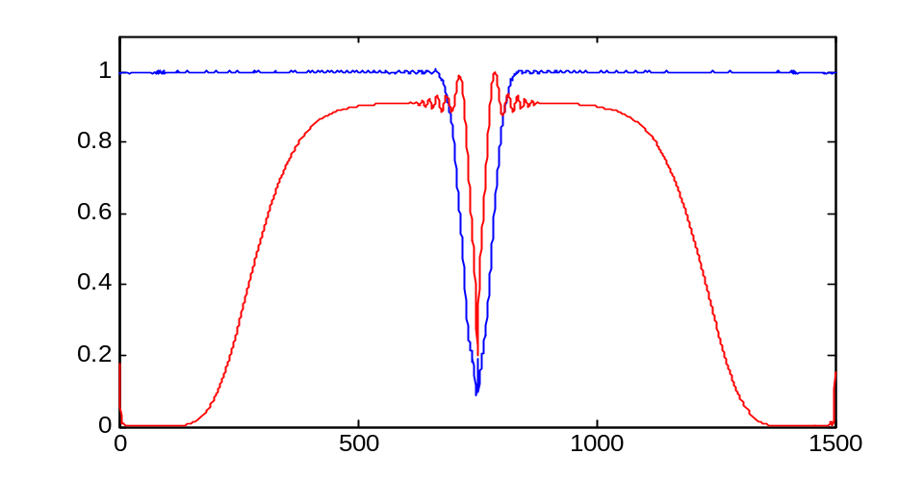
Red: compensated signal
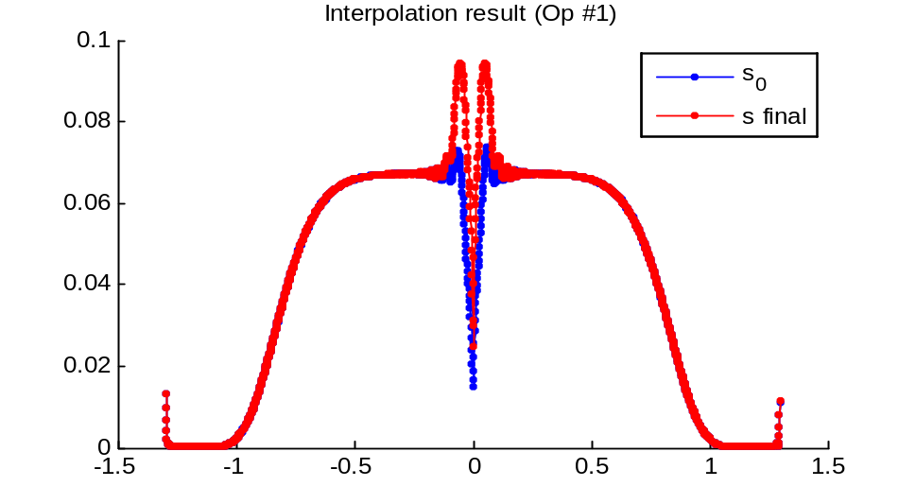
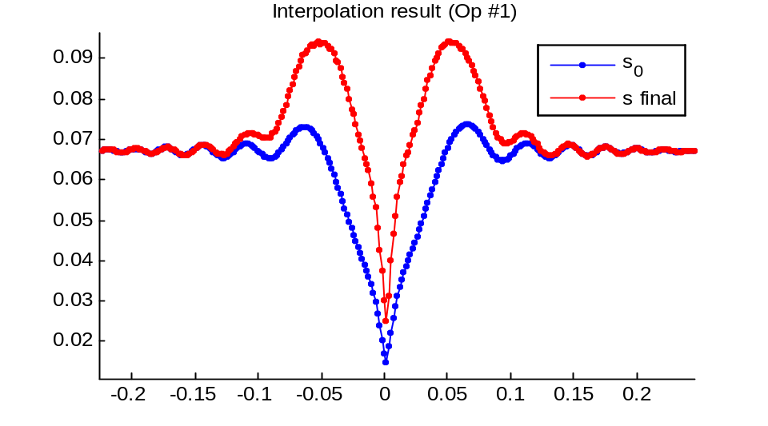 Enlarged
- Compensation is not satisfactory.

588.fid – Interpolation using nearest neighbor contribution

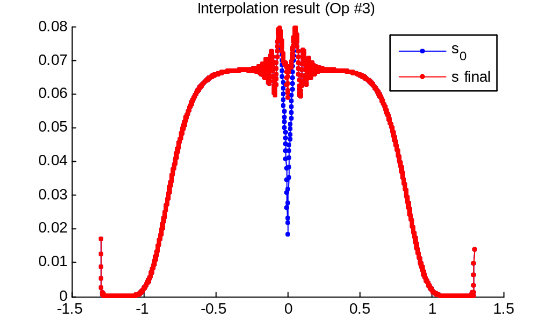
- Compensation is not satisfactory.

588.fid – Phase based interpolation – option 2.1
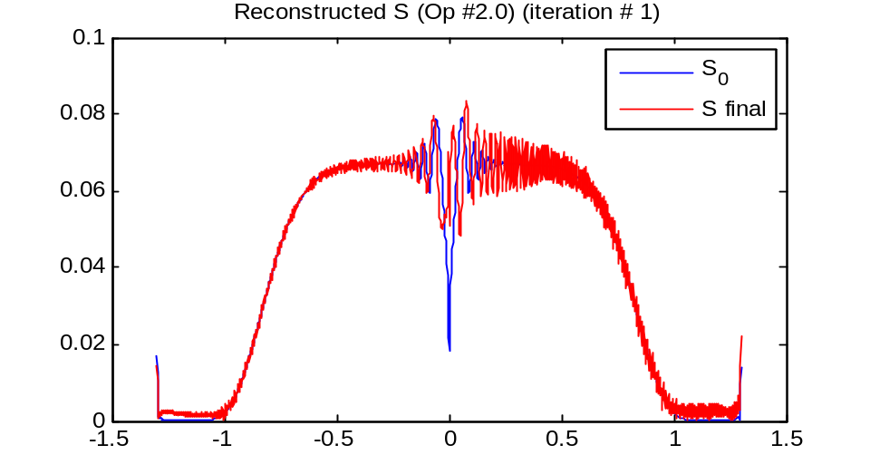

Blue – initial reconstructed signal ; Black – Reconstructed interface region
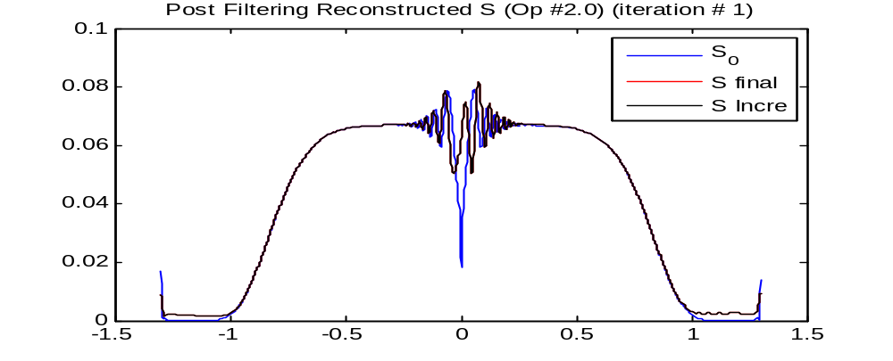
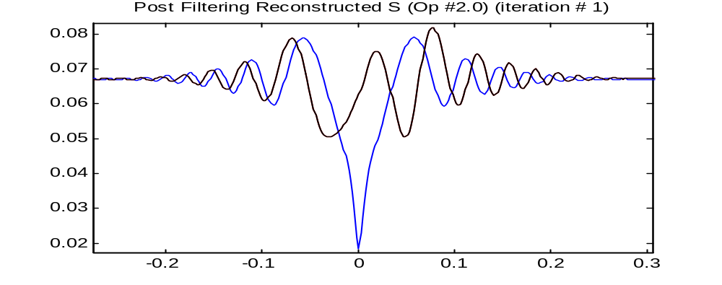
- wiggling problem is not solved
- Compensation is not satisfactory.

588.fid – Phase based interpolation – option 2.2
Blue – reference response
Black – filtered reference response – localized around the interface region.
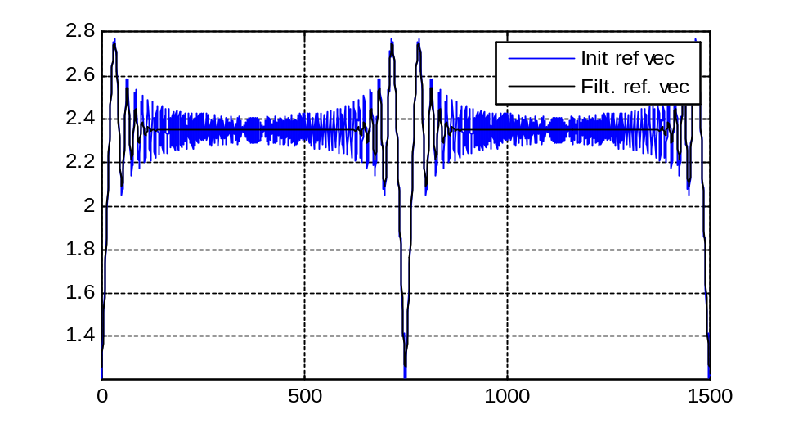Reference mask
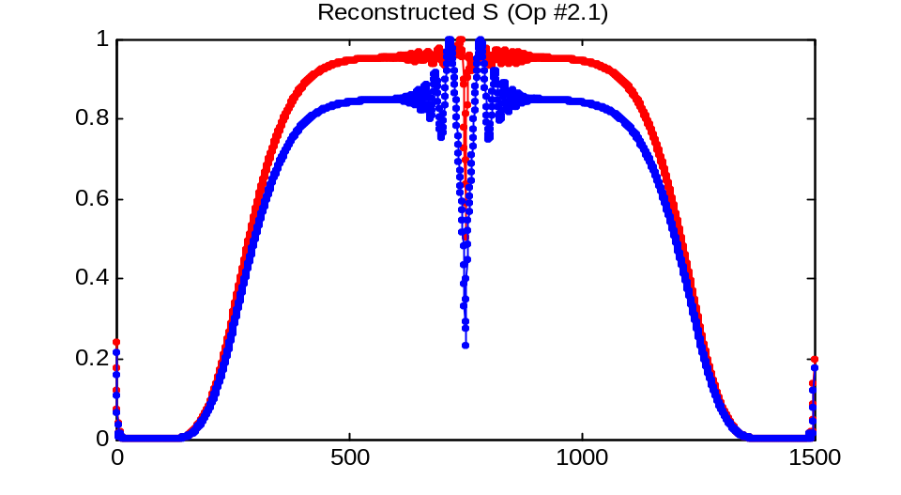Manually filtered reference mask
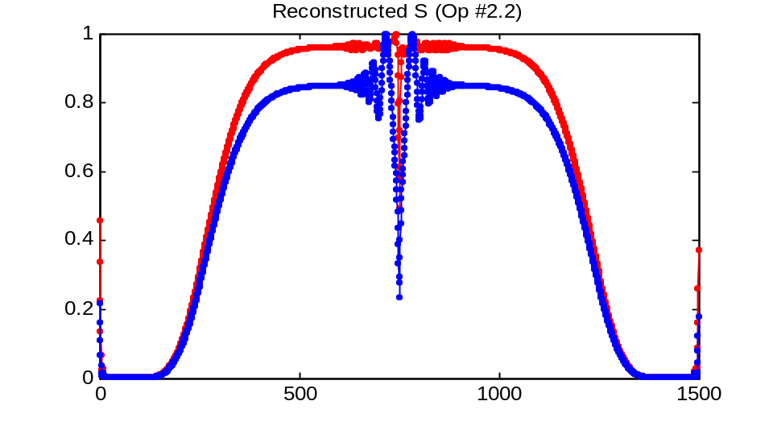FT filtered reference mask
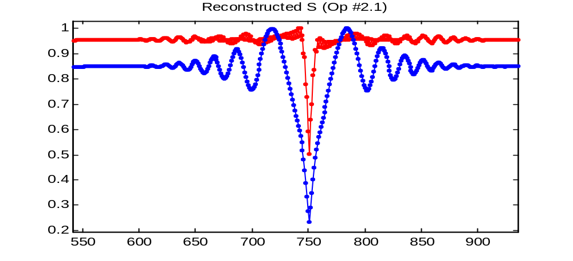Enlarged
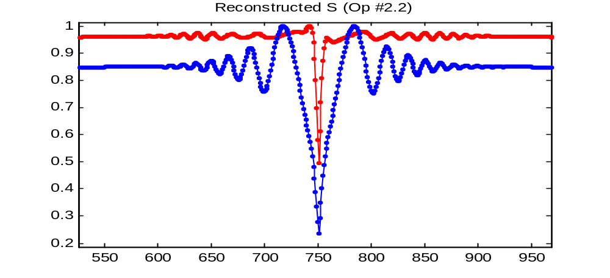Enlarged

